STOCK PRICE PREDICTION
AIM:
The aim is to create a model to get the prediction of the "New York Stock Exchange"
Here we have the value of 2016 whole year, 80% of the value will be used to train the model, and the remaining 20% test the model.

Dataset consists of the following files:
prices.csv: raw, as-is daily prices. Most of the data spans from 2010 to the end of 2016, for companies new on the stock market date range, is shorter. There have been approx. 140 stock splits in that time, this set doesn't account for that.
prices-split-adjusted.csv: same as prices, but there have been added adjustments for splits.
securities.csv: a general description of each company with the division on sectors
fundamentals.csv: metrics extracted from annual SEC 10K fillings (2012-2016), should be enough to derive most of the popular fundamental indicators

Install the following packages
This is to solve any environment/package related issues

conda update --all –yes

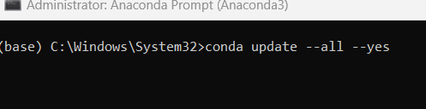

conda install -c conda-forge keras

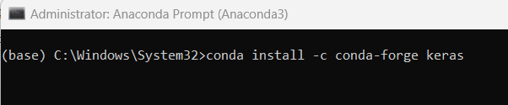

conda install -c conda-forge tensorflow

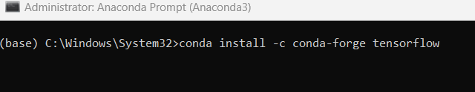

Import Libraries
import numpy as np
import pandas as pd
import os
import matplotlib.pyplot as plt
import warnings
warnings.filterwarnings('ignore')
from matplotlib.pylab import rcParams
rcParams['figure.figsize'] = 15, 6
Check the current working directory

display (os.getcwd())

Change the current working directory

os.chdir ('C:\\Noble\\Training\\Acmegrade\\Machine Learning\\Projects\\PRJ Stock Price Prediction\\')
display (os.getcwd())

Read and display the data set
# calling the file in nyse named prices.csv

df =pd.read_csv("prices.csv", header=0)
display (df)

Data Description
The table consists of data of New York Stock Exchange consist of 851264 entries

Column1—Date: The date here is from 05-01-2016 to 30-12-2016 i.e of the year 2016 with many company performances

Column2—Symbols: Symbols are code for 501 companies i.e each symbol is allotted to each corporation. Other way we consider it as company names

Column3—open: Open is the stock opening price of the date.

Column4—close: Close is the stock closing price of the date

Column5—low: Low is the lowest price of the date

Column6—high: High is the highest price of the date.

Display the shape
print(df.shape)

Display the column names
print(df.columns)

Value count (Number of records by company)
df.symbol.value_counts()

Unique Values
df.symbol.unique()

Number of Unique Values
display(df.symbol.unique().shape)

First 20 Unique values
df.symbol.unique()[0:20]

Number of Records
print(len(df.symbol.values))

Display Info
df.info()

Describe the column
# Gives the details of each column of the dataset like mean, max, etc
df.describe()

Check for NULL Values
# checking whether there is any null value in the dataset
# .sum() will give the total no. of null value column-wise

df.isnull().sum()

Get all Unique Dates
df.date.unique()

Display Date as Data Frame
pd.DataFrame(df.date.unique())

Check for Duplicate Records
df.duplicated().sum()

Load the File
#Calling the file in nyse named securities.csv, It has the company details
comp_info = pd.read_csv('securities.csv')
comp_info

Data description
Table consists of 504 entries of descriptions of companies.
column1-- Ticker Symbol It is the symbol of companies, same as the symbol in df

column2-- Security It is the name of a corporation like amazon.com Inc
column4-- GICS Sector It is the type of the company. eg Adobe Systems Inc is Information Technology
column5-- GICS Sub Industry It is the sub department of the type of company. eg Adobe Inc is Application Software
column6-- Address of headquarters It is company head base(main office) location

Check for Unique count
comp_info["Ticker symbol"].nunique()

Check for info
comp_info.info()

Check for Null Values
comp_info.isnull().sum()

Describe the Details
comp_info.describe()

Search for Particular company details
# for locating specific data here.... in security column of string that starts with "Face"
comp_info.loc[comp_info.Security.str.startswith('Face') , :]

Example – Search for another company - Acc
comp_info.loc[comp_info.Security.str.startswith('Acc') , :]

Select any 6 companies using the above method for visualizations on respective opening and closing stock prices.
- Yahoo Inc,
- Xerox Corp,
- Microsoft Corp
- Facebook
- Adobe Systems Inc
- Goldman Sachs Group

# here we locate Ticker symbol of company with security like Yahoo, Xerox, Adobe etc, then taking their no. of times entry and thier "Ticker symbol"
In the result, left side 6.181,212 etc the index values corresponds to the selected companies from comp info

comp_plot = comp_info.loc[(comp_info["Security"] == 'Yahoo Inc.') | (comp_info["Security"] == 'Xerox Corp.') | (comp_info["Security"] == 'Adobe Systems Inc')
| (comp_info["Security"] == 'Microsoft Corp.') | (comp_info["Security"] == 'Adobe Systems Inc')
| (comp_info["Security"] == 'Facebook') | (comp_info["Security"] == 'Goldman Sachs Group') , ["Ticker symbol"] ]["Ticker symbol"]
print(comp_plot)
For Loop to display 6 Company names
for i in comp_plot:
print (i)

Create a function to plot Graphs for selected companies opening stock and closing stock against time
def plotter(code):
# Function used to create graphs for 6 companies
global closing_stock ,opening_stock
#creating plot of all 6 company for opening and closing stock total 12 graphs
# Below statement create 2X2 empty chart
f, axs = plt.subplots(2,2,figsize=(15,8))
# total 12 graphs
# creating plot opening prize of particular company
plt.subplot(212)
#taking name of the company as code, get all records related to one company
company = df[df['symbol']==code]
#taking the values of one company and taking its open column values to 1D array
company = company.open.values.astype('float32')
#reshaping the open stock value from 1D to 2D .
company = company.reshape(-1, 1)
# putting the value of company in opening_stock
opening_stock = company
# plotting the data with green graph between "Time" and "prices vs time"

plt.grid(True)# enalbling the grid in graph
plt.xlabel('Time') # setting X axis as time
# setting Y axis as company name + open stock prices
plt.ylabel(code + " open stock prices")
plt.title('prices Vs Time') # setting title
plt.plot(company , 'g') # calling the graph with green graph line

# creating plot closing prize of particular company
plt.subplot(211)
#taking name of the company as code
company_close = df[df['symbol']==code]
#taking the values of one company and taking its close column values
company_close = company_close.close.values.astype('float32')
#reshaping the open column value in 1D and calling it closing_stock
# -1 for unknown dimension
company_close = company_close.reshape(-1, 1)
# putting company_close value in closing_stock
closing_stock = company_close
# plotting the data graph between "Time" and "prices vs time"
plt.xlabel('Time') # setting x axis as time
plt.ylabel(code + " close stock prices")# setting y axis as company name + open stock prices
plt.title('prices Vs Time') # setting title as price vs time
plt.grid(True) # enabling the grid in graph
plt.plot(company_close , 'b') #creating the data graph in blue graph line
plt.show() # calling the graph

Calling the graphs through the function
for i in comp_plot:
plotter(i)

Plot Summary
Adobe report
As we can see, that close and open started around 38 points and shows an increasing growth with time. The open and close graph closes at a very high position (around 105) compared to the start.

Facebook report
As the graph shows, open and close started around 30 points. And from there, it shows a bit downfall time 150. But then it shows a massive uprise and ends at the120 points for both open and close.

Goldman Sachs
As we see in graphs of open and close stocks, we see that Goldman has taken many up and downs almost the whole journey. It starts from high points than others around 175 points and faced major downfall but at last, it reached higher to 240 points.

Microsoft
As the graphs explain open and close stock for Microsoft started from 30 points. And from there they show total elevation to 65 points. It is a great option for investment

Xerox
As the graphs suggest for Xerox, it started from very low points of 9 and from there it struggled to progress. There was a major fall after some time and in the end, the stock prices are still nearly the same.
Yahoo
As we see in the graphs, Yahoo prices remained the same for some time. But then they show effective progress. And at the end, they go to around 40 points.
Extract closing stock of one company, here YHOO
stocks= np.array (df[df.symbol.isin (['YHOO'])].close)
print(stocks)

Display Shape
display (stocks.shape)

Convert stock to 2D array
stocks = stocks.reshape(len(stocks) , 1)
print (stocks.shape)
print(stocks)

Remaining Steps to be Followed

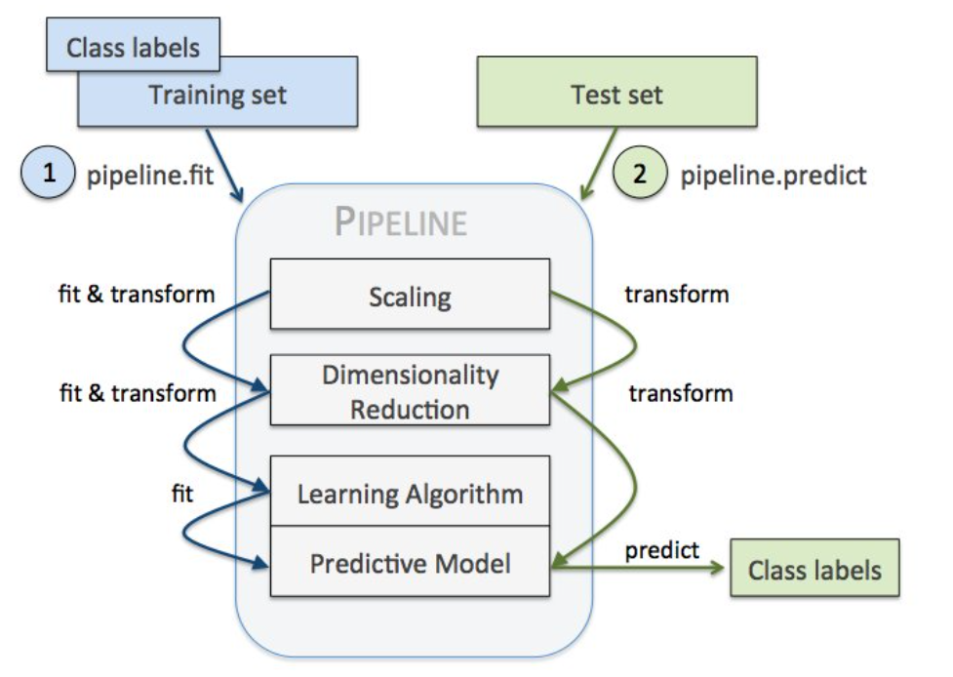

Min Max Scaler
Feature scaling the vector for better model performance.
from sklearn.preprocessing import MinMaxScaler
#scaling features between 0 and 1
scaler = MinMaxScaler(feature_range=(0, 1))
stocks = scaler.fit_transform(stocks)
display (stocks)

Train Test Split (80 % Training and 20 % Test Data)
Total Number of Records
print (stocks.shape)

# 80 % Training record count
train = int(len(stocks) * 0.80)
print (train)

# 20 % record count (Total – 80%)
test = len(stocks) - train
print (test)

Training Data
#divinding the values of stocks data to train from 0 to 1409 i.e 80% data
train = stocks[0:train]
display (train.shape)
print(train)

Test Data
#divinding the values of stocks data to test from train ending to stock data ending i.e rest 20% data
test = stocks[len(train) : ]
display(test.shape)
display (test)

Function to prepare the data, use two previous values to predict for third data

#creating function to create trainX,testX and target(trainY, testY)
def process_data(data , n_features):
dataX, dataY = [], [] # creating data for dataset and dividing inta X,Y
for i in range(len(data)-n_features):
# taking i range from total size- 3
a = data[i:(i+n_features), 0]
# Here a is value of data from i to i+ n_features, ie two values and put it in dataX
dataX.append(a) #putting a in dataX
#here dataY takes the value of data of i + n_features
dataY.append(data[i + n_features, 0])
# putting i+ n_features in dataY
return np.array(dataX), np.array(dataY)
# returning dataX and dataY in array

Call the function to prepare training data
n_features:
This is the number of previous period’s data required to do the current prediction. In this case, use two previous records data to predict the current value.
n_features = 2
# Here we create train X, Train Y and test X, Test Y data where trainX, testX has two value is each block

trainX, trainY = process_data(train, n_features)
print(trainX.shape , trainY.shape)

Call the function to prepare test data - n_features = 2

testX, testY = process_data(test, n_features)
print (testX.shape , testY.shape)

Call the function to prepare full data - n_features = 2
stocksX, stocksY = process_data(stocks, n_features)
print (stocksX.shape , stocksY.shape)

Display the First 10 Records from Train X
display (trainX[:10])

Display the First 10 Records from TrainY
display (trainY[:10])

Reshape to 3D array to use for LSTM /Deep Learning model
# reshaping trainX and testX to use in deep learning model
trainX = trainX.reshape(trainX.shape[0] , 1 ,trainX.shape[1])
display (trainX.shape)
Reshape to 3D array test X
testX = testX.reshape(testX.shape[0] , 1 ,testX.shape[1])
display (testX.shape)
Reshape to 3D array full data set
stocksX= stocksX.reshape(stocksX.shape[0] , 1 ,stocksX.shape[1])
display (stocksX.shape)

Import Libraries
# helps us do mathematical operations
import math
# for setting layers one by one neural layer in model
from keras.models import Sequential
# types of layers
from keras.layers import Dense , BatchNormalization , Dropout , Activation
# types of RNN
from keras.layers import LSTM , GRU
#It puts the data in between given range to set data before putting layer
from sklearn.preprocessing import MinMaxScaler
# In this method the errors in column is squared and then mean is found
from sklearn.metrics import mean_squared_error
# Optimizers used
from keras.optimizers import Adam , SGD , RMSprop
# If Keras Optimizers Gives error use from Tensor Flow
from tensorflow.keras.optimizers import Adam

keras
Keras contains numerous implementations of commonly used neural-network building blocks such as layers, objectives, activation functions, optimizers, and a host of tools to make working with image and text data easier to simplify the coding necessary for writing deep neural network code.

RNN
recurrent neural network processes sequences — whether daily stock prices, sentences, or sensor measurements — one element at a time while retaining a memory (called a state) of what has come previously in the sequence.Recurrent means the output at the current time step becomes the input to the next time step. At each element of the sequence, the model considers not just the current input, but what it remembers about the preceding elements.

Optimizers
Optimization algorithms helps us to minimize (or maximize) an Objective function (another name for Error function) E(x) which is simply a mathematical function dependent on the Model’s internal learnable parameters which are used in computing the target values(Y) from the set of predictors(X) used in the model.

Create Check Points

#Checkpointing the model when required and using other call-backs.
filepath="stock_weights1.hdf5"
from keras.callbacks import ReduceLROnPlateau , ModelCheckpoint
# ReduceLROnPlateau- This reduce the learning rate when the matrix stop improving or too close to reduce overfitting
lr_reduce = ReduceLROnPlateau(monitor='val_loss', factor=0.1, min_delta =0.0001, patience=1, verbose=1)
#This check point will stop processing, if the model is not improving.
checkpoint = ModelCheckpoint(filepath, monitor='val_loss', verbose=1, save_best_only=True, mode='max')

Callbacks
A callback is a set of functions to be applied at given stages of the training procedure. You can use callbacks to get a view on internal states and statistics of the model during training. You can pass a list of callbacks (as the keyword argument callbacks) to the .fit() method of the Sequential or Model classes. The relevant methods of the callbacks will then be called at each stage of the training.

ReduceLROnPlateau
Reduce learning rate when a metric has stopped improving.Models often benefit from reducing the learning rate by a factor of 2-10 once learning stagnates. This callback monitors a quantity and if no improvement is seen for a 'patience' number of epochs, the learning rate is reduced.

ModelCheckpoint
Save the model after every epoch.filepath can contain named formatting options, which will be filled with the values of epoch and keys in logs (passed in on_epoch_end).

Create the model – Fully connected Layer
# creating model for training data using sequential to give series wise output between layers
model = Sequential()
# GRU or Gated Recurrent Unit used for matrix manipulation within Recurrent layer
#This is the input Layer
model.add(GRU(256 , input_shape = (1 , n_features) , return_sequences=True))
#dropout is used to remove overfitting data on each layer of neural network
model.add(Dropout(0.4))
#Long Short Term Memory is a type of RNN specially used for time series problems
model.add(LSTM(256))
#dropout is used to remove overfitting data on each layer of neural network
model.add(Dropout(0.4))
#Dense layer are fully connected neural networks
model.add(Dense(64 , activation = 'relu'))
#This is the output Layer, Output is only one neuron
model.add(Dense(1))
#for getting the details of our models
print(model.summary())

Compile the Model
# Selecting the loss measurement metrics and optimizer for our model, to find out mean square error
model.compile(loss='mean_squared_error', optimizer=Adam(lr = 0.0005) , metrics = ['mean_squared_error'])

Fit the Model
# fitting the data i.e training the trainX, to relate to trainY
# epochs is the times each data in send to fit
# batch size is the size of information send at a time
# validation_data is the validation or data used for testing
history = model.fit(trainX, trainY, epochs=100 , batch_size = 128 ,
callbacks = [checkpoint , lr_reduce] , validation_data = (testX,testY))

Predict the value for testX, display top 10 records

test_pred = model.predict(testX)
display (test_pred [:10])

Inverse Transform the data – Convert the data to Original form
test_pred = scaler.inverse_transform(test_pred)
display (test_pred [:10])

Reshape and Display Original Data
testY = testY.reshape(testY.shape[0] , 1)
#Converting reshaped list in 1D array so that it will be efficient in plotting
testY = scaler.inverse_transform(testY)
# taking testY from 1 to 10
display (testY[:10])

Display the accuracy
from sklearn.metrics import r2_score
r2_score(testY,test_pred)

Plot the Graph Actual and Predicted Data
# Ploting the graph of stock prices with time
print("Red - Predicted Stock Prices , Blue - Actual Stock Prices")
plt.rcParams["figure.figsize"] = (15,7)
# testY is the blue line
plt.plot(testY , 'b')
# pred is the red line
plt.plot(test_pred , 'r')
# Setting x axis as time
plt.xlabel('Time')
# Setting y axis as stock prices
plt.ylabel('Stock Prices')
# setting title
plt.title('Check the accuracy of the model with time')
# enabling grids in graph
plt.grid(True)
# it call the graph with labels, titles, lines
plt.show()

Prediction Training Data and Check Accuracy
train_pred = model.predict(trainX)
train_pred = scaler.inverse_transform(train_pred)
trainY = trainY.reshape(trainY.shape[0] , 1)
trainY = scaler.inverse_transform(trainY)
print ('Display Accuracy Training Data')
display (r2_score(trainY,train_pred))

Plot the Graph

# Ploting the graph of stock prices with time - Training Data
print("Red - Predicted Stock Prices , Blue - Actual Stock Prices")
plt.rcParams["figure.figsize"] = (15,7)
plt.plot(trainY , 'b')
plt.plot(train_pred, 'r')
plt.xlabel('Time')
plt.ylabel('Stock Prices')
plt.title('Check the accuracy of the model with time')
plt.grid(True)
plt.show()

Prediction Full Data

stocks_pred = model.predict(stocksX)
stocks_pred = scaler.inverse_transform(stocks_pred)
stocksY = stocksY.reshape(stocksY.shape[0] , 1)
stocksY = scaler.inverse_transform(stocksY)
print ('Display Accuracy Training Data')
display (r2_score(stocksY,stocks_pred))

Plot the Graph
plt.rcParams["figure.figsize"] = (15,7)
plt.plot(stocksY , 'b')
plt.plot(stocks_pred, 'r')
plt.xlabel('Time')
plt.ylabel('Stock Prices')
plt.title('Check the accuracy of the model with time')
plt.grid(True)
plt.show()

Concat original and prediction data

# Extract the data related to company - YHOO
results= df[df.symbol.isin (['YHOO'])]
# Update the data frame starting with 2nd records , since first prediction is for 2nd record
results= results [2:]
# Reset the index 0, 1,2 etc
results = results.reset_index(drop=True)
# Convert Predicted Value to Data Frame
df_stocks_pred= pd.DataFrame(stocks_pred, columns = ['Close_Prediction'])
# Concat Original and prediction data
results= pd.concat([results,df_stocks_pred],axis =1)
results.to_csv('results.csv')
display(results)

